Handout no. 12

|  |  |
| --- | --- |
| **Name** | **M.Umar Saleem, M.Usama, Abdul Jabbar** |
| **Reg. No** | **2019-EE-356,366,376** |
| **Marks/Grade** |  |

# EXPERIMENT # 12

**Modeling of Differential Protection Relay in MATLAB/ Simulink for**

**Transformer protection**

**Objective:**

At the end of this lab session students will be able to

➢ Design of differential protection relay on Simulink /MATLAB.

**Introduction:**

A relay is usually an electromechanical device that is actuated by an electrical current. The current flowing in one circuit causes the opening or closing of another circuit. Relays are like remote control switches and are used in many applications because of their relative simplicity, long life, and proven high reliability. Relays are used in a wide variety of applications throughout industry, such as in telephone exchanges, digital computers and automation systems. Highly sophisticated relays are utilized to protect electric power systems against trouble and power blackouts as well as to regulate and control the generation and distribution of power. In the home, relays are used in refrigerators, washing machines and dishwashers, and heating and air-conditioning controls.

Although relays are generally associated with electrical circuitry, there are many other types, such as pneumatic and hydraulic. Input may be electrical and output directly mechanical. All relays contain a sensing unit, the electric coil, which is powered by AC or DC current. When the applied current or voltage exceeds a threshold value, the coil activates the armature, which operates either to close the open contacts or to open the closed contacts. When a power is supplied to the coil, it generates a magnetic force that actuates the switch mechanism **Tool:**

Simulink/Matlab

**Differential Protection Relay:**

Power systems divided into zones of protection like bus, generator, transformer, transmission line, capacitor, motor, etc. Protection systems applied to these may be broadly classified as unit and non-unit protection systems. Unit systems bounded by CT locations. Major advantage of unit over non-unit is selectivity and speed. Most of the relays operate when any quantity exceeds beyond a predetermined value for example over current relay operates when current through it exceeds predetermined value. But the principle of differential relay is somewhat different. It operates depending upon the difference between two or more similar electrical quantities.

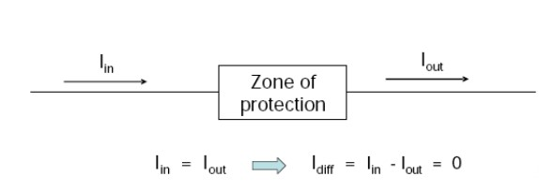

In reality provision has to be made for nonzero differential quantities under normal, healthy conditions. These could result due to line charging current, CT mismatching, the transformer tap changer, etc. Provision is thus made for ways to prevent relay operation which could result due to differential current being present under normal system conditions. This is classically done by deriving a restraint quantity from the terminal currents (biased differential protection).

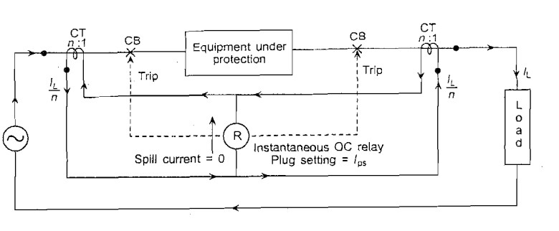

**Zone of Protection:**

The differential scheme generates a well-defined and closed zone of protection. This zone encompasses everything between the two CTs. Ideally, a differential scheme is supposed to respond only to internal faults, and restrain from tripping on external faults.

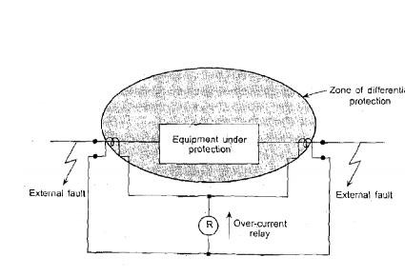

**Protection of Transformer using Differential Relay in Simulink:**

The power system is designed in Simulink. The zone which is protected using differential protection scheme includes transformer. The two CTs is in this zone which senses the voltage and current and send the information to relay. The relay take information and send trip signal to breaker to isolate the faulty zone. The fault is generated in zone in which transformer is protected and outside the zone and result is concluded. The relay should only isolate the zone which is protected and should not trip the breakers when fault occurs outside the zone.

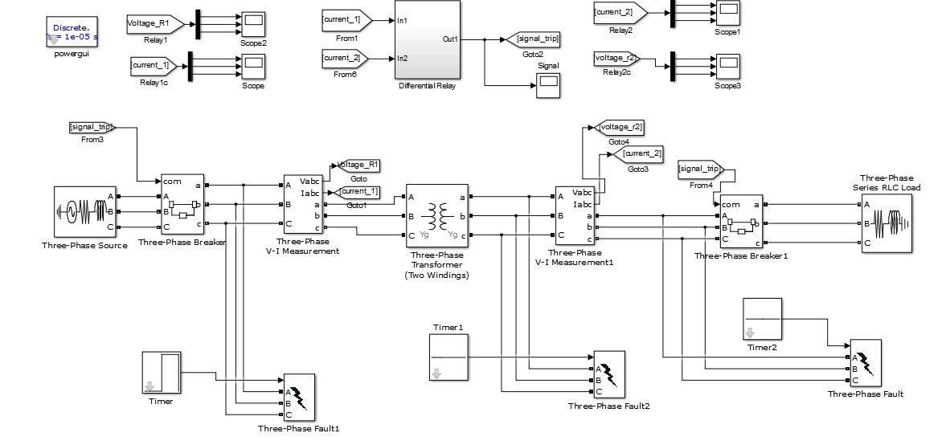

**Design of Relay:**

The numerical differential relay is designed in Simulink. The values from CTs is taken through communication system and logic is designed to isolate only faulty zone. The difference of two CTs values is taken and compare with some threshold value if the value is greater than it will send trip signal to breaker to operate.

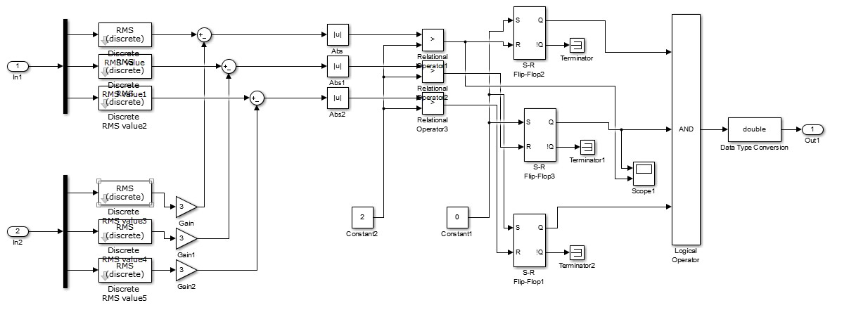

**Circuit:** 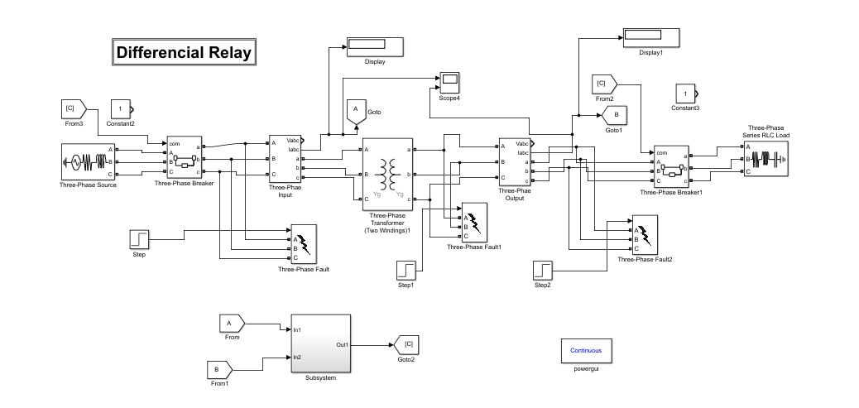

**Relay Circuit:**

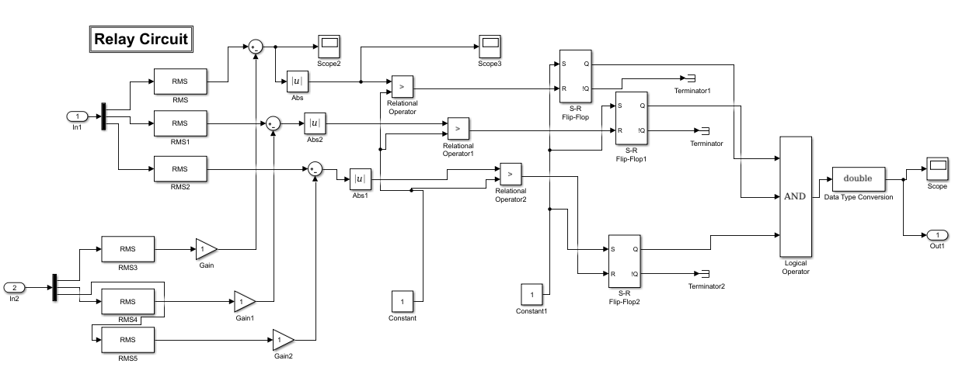

1. **When fault is occurred outside the zone?**

Relay should not operate for this fault.

**RMS Value**

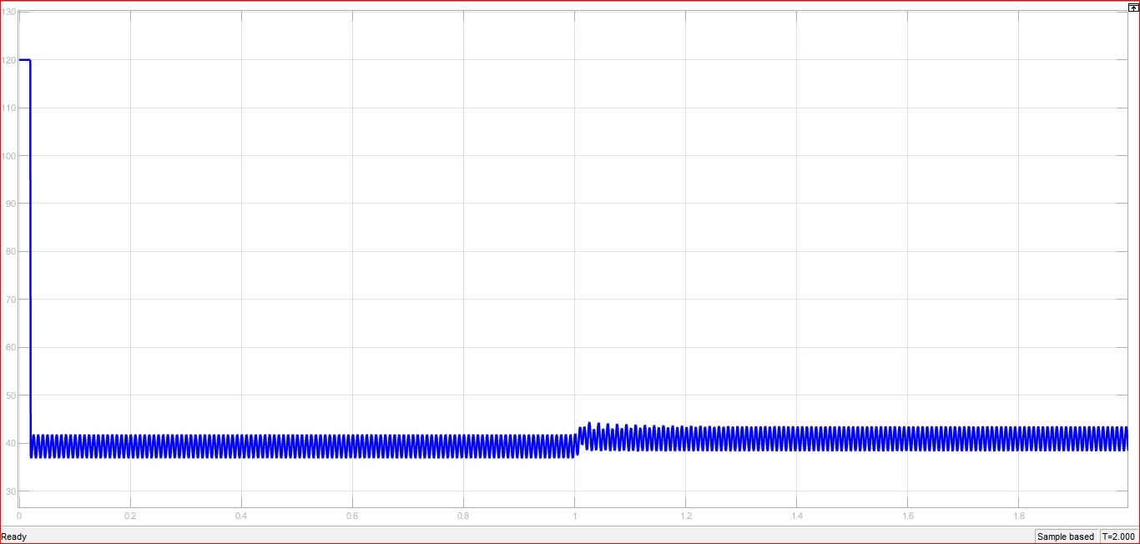

**Difference Value**

**Relay signal**

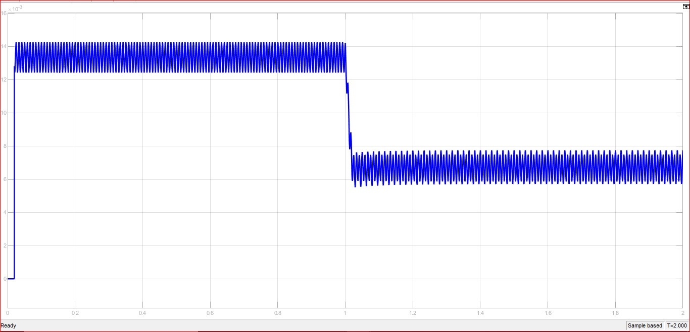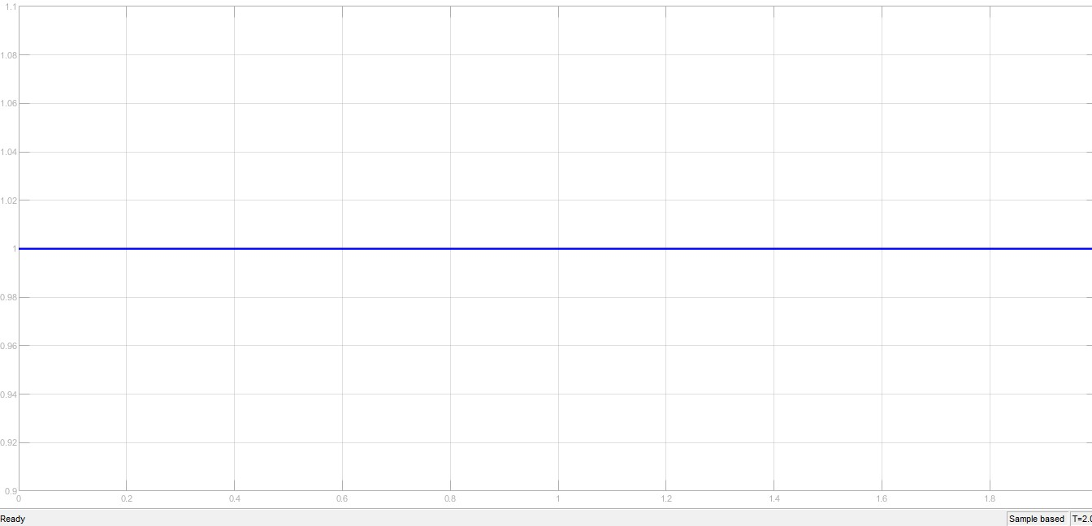

1. **When fault is occurred inside zone?**

Relay must operate for this fault.

**RMS VALUE**

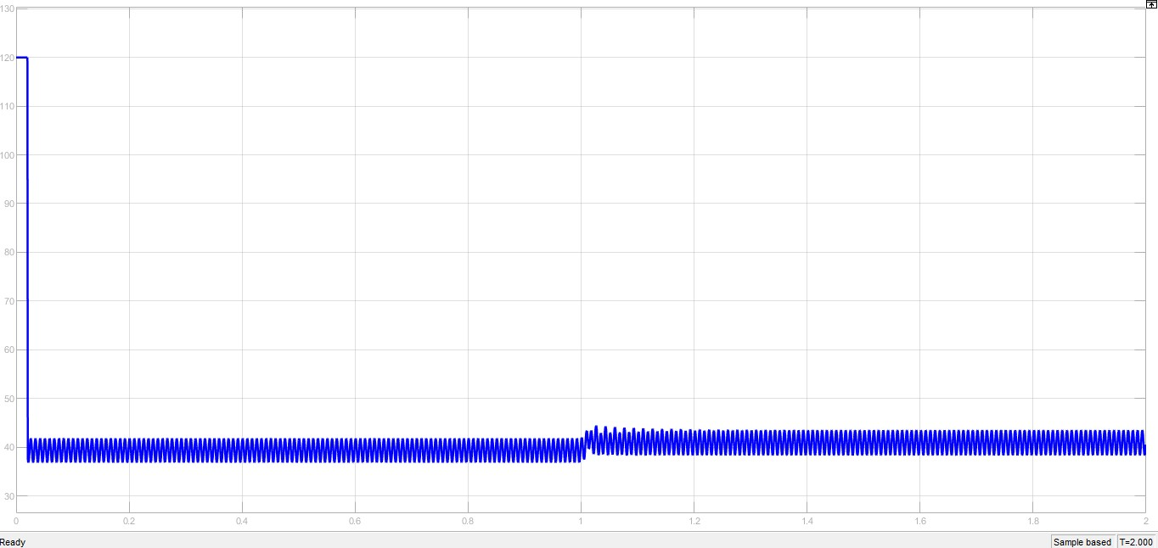

**Graph after difference:**

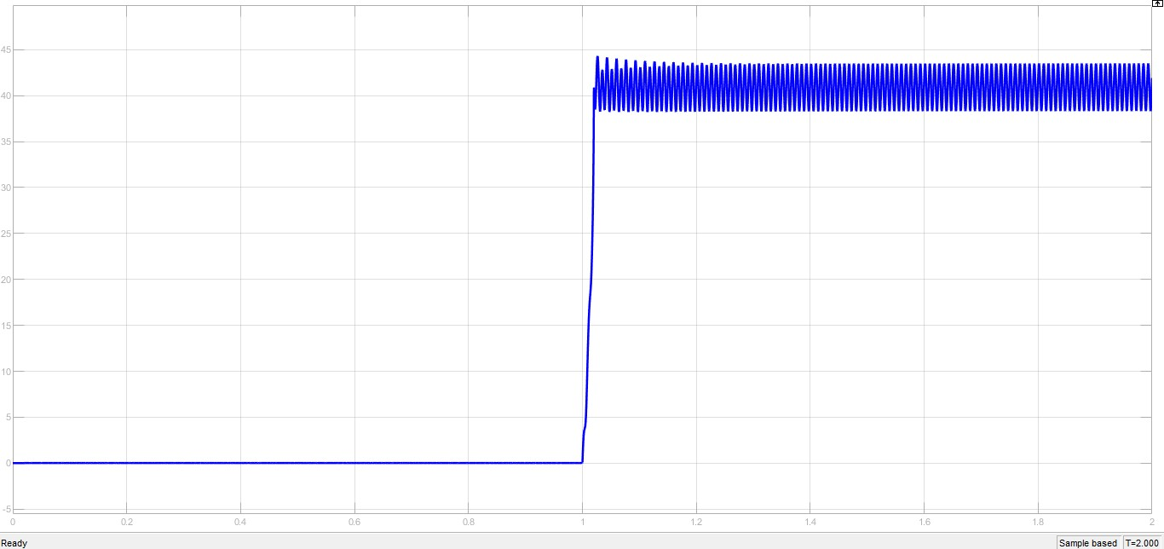

**RELAY SIGNAL**

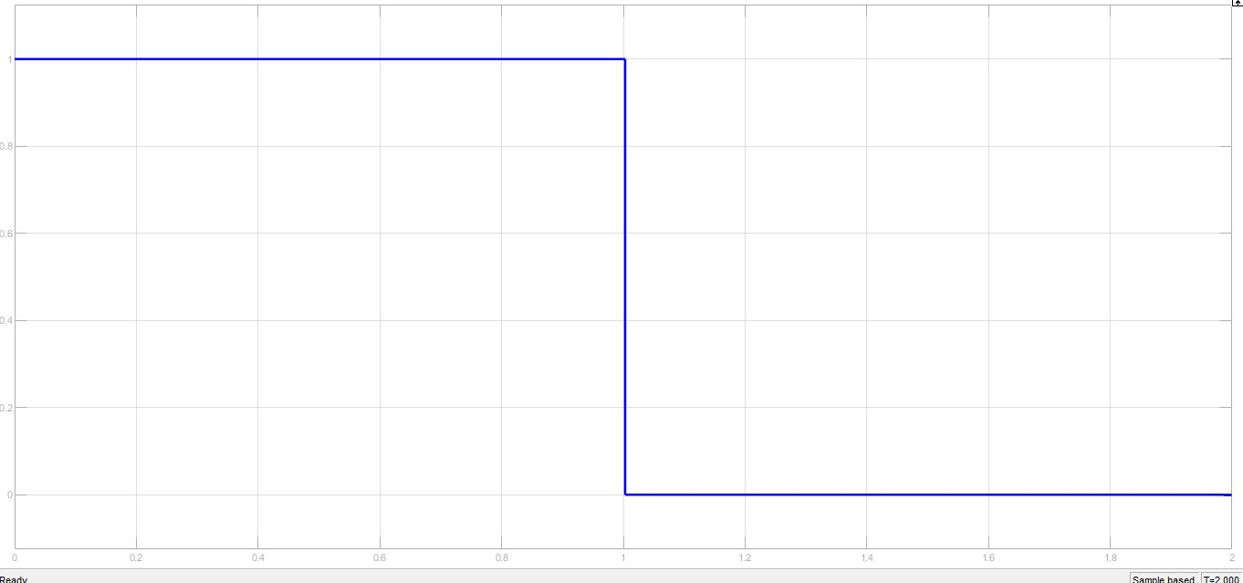

This clearly shows that when fault is occurred inside relay zone it will operate as shown above.

**Breaker Operation when Relay gives tripping signal.**

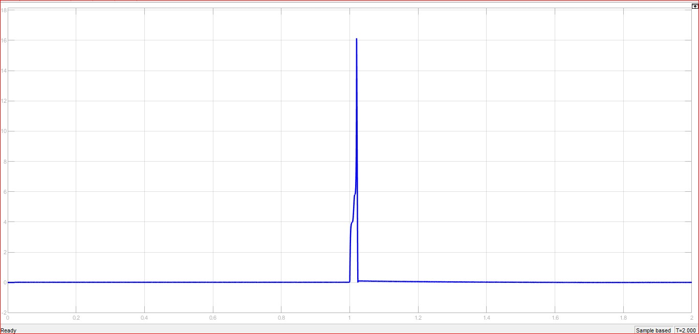

**Conclusion:**

In this lab we have learnt that Relays are like remote control switches and are used in many applications because of their relative simplicity, long life, and proven high reliability.

In this lab we designed a differential relay. The differential relay is one that operates when there is a difference between two or more similar electrical quantities exceeds a predetermined value. In differential relay scheme circuit, there are two currents come from two parts of an [electrical power](https://www.electrical4u.com/electric-power-single-and-three-phase/) circuit. These two currents meet at a junction point where a relay coil is connected. According to [Kirchhoff Current Law,](https://www.electrical4u.com/kirchhoff-current-law-and-kirchhoff-voltage-law/#Kirchhoff%27s-Current-Law) the resultant current flowing through the relay coil is nothing but summation of two currents, coming from two different parts of the electrical power circuit. If the polarity and amplitude of both the currents are so adjusted that the phasor sum of these two currents, is zero at normal operating condition. Thereby there will be no [current](https://www.electrical4u.com/electric-current-and-theory-of-electricity/) flowing through the relay coil at normal operating conditions. But due to any abnormality in the power circuit, if this balance is broken, that means the phasor sum of these two currents no longer remains zero and there will be non-zero current flowing through the relay coil thereby relay being operated. When comparing the current entering a line and the current leaving it, if more current enters the protected line and it leaves, then the extra current must flow in the fault. The difference between the two electrical quantities can operate a relay to isolate the circuit. And we used Current difference for relay operation.